University of Kent

CO553 Sprint Three Report

A report consisting of our sprint review and retrospective

Group C2-3

Agile Development and Software Security B (CO553)

CO553 Scrum Project Report

Product and Sprint Backlog

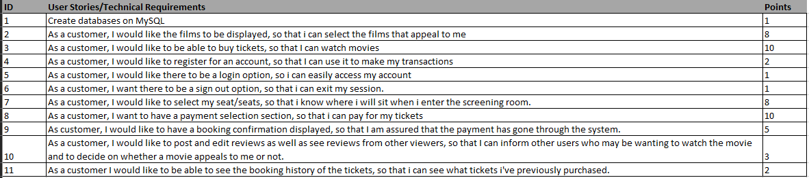

Figure 1: User Stories

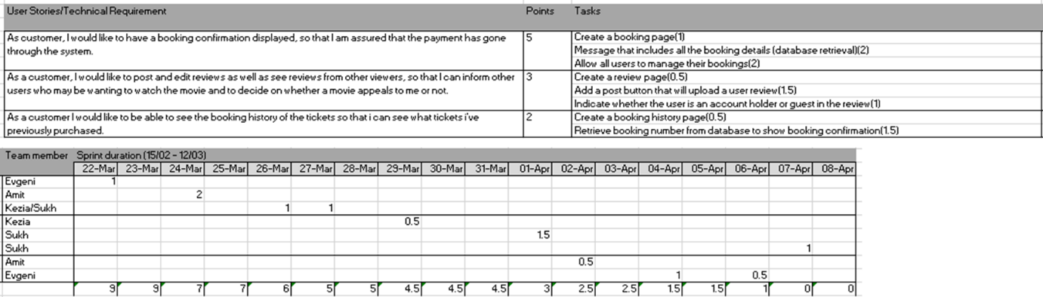

Figure 2: Sprint Backlog

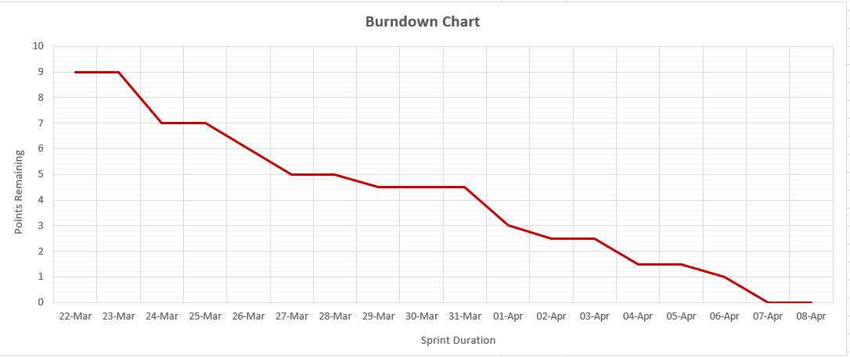

Figure 3: Burndown Chart:

Sprint Review

The final sprint required more frequent meetings and more time towards the last tasks for our project. Therefore, at the beginning of the third sprint, we ensured all tasks were divided equally as we had to complete many coding tasks on time. Pair programming was used to bring the best out of each person in the group. Since our second sprint, we continued to have frequent meetings on discord to communicate further about the project.

 Following up from our practical meeting we made various changes to our cinema booking system to make it better which were suggested. This resulted in an entire redesign of the website using Bootstrap to make it appear more professional. Once the redesign was complete, we filled all previous placeholders with movie screen captures to make the website feel like an actual cinema booking website. Furthermore, following up on previous feedback that had been given to us we also updated the booking page so that the selection of seating is much more visible in terms of seat availability and also the timings in which customers can select a particular movie.

Sprint Retrospective

The third sprint overall was straightforward due to the effective communication between the group. We had increased our meetings for everyone to be aware of the last tasks that we had to do which worked out very well. Once again, we were more open with each other when it came to concerns of the group or help that was needed to do with completing tasks. The openness of the communication has been a big factor within this last sprint as the honesty between each member has allowed us to fix any issues raised in previous sprints and as a result of this the team morale and motivation to succeed has been exceptional and because of this we have enjoyed working with each other and have been able to work through this sprint with no issues.

Furthermore, we decided to lessen our tasks for the final sprint to make them more feasible to achieve which worked well. This meant more effectiveness for everyone in the group. Overall, this allowed us to meet our objectives and complete our sprint three tasks in a shorter time frame. In terms of anything that we could change as a group, we discussed how this sprint has been carried out and it has shown us that there is nothing that we could have done to change the work we have produced due to using all the previous feedback we have been given and also the peer feedback we have given each other throughout the project. This enabled us to find very effective ways of completing tasks in our project. We also have been able to use methods such as git branching and pair programming to our advantage and understand the benefits these methods bring when working in a group.